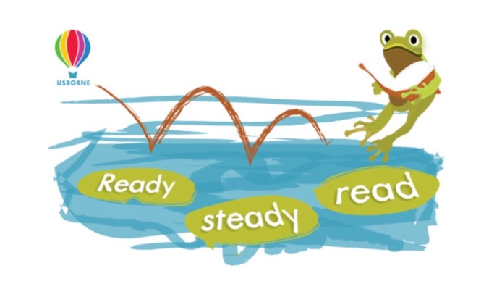
Dear Parent/Guardian,

To celebrate and encourage a lifelong love of books and reading at home and school, I am excited to share that we will be running a Sponsored Reading event between 31st May and 9th June.

The project is being organised in conjunction with our local Usborne Organiser, Melanie Mitchell, and all the money raised will go towards brand new books for our School for your children to enjoy.

In addition to the sponsorship money, Usborne will also donate up to 60% of the total raised in EXTRA FREE BOOKS for us. This means for every £600 raised, we will get an extra £360 in FREE Usborne books!

Please help us to enhance our reading and learning resources for your children by spending a small amount of time each day reading with your child, and gathering sponsorship from friends and family. It’s not just books that you can enjoy together; comics, magazines, recipes, menus, your favourite websites - anything with words that you can read together and your children enjoy.

Please find enclosed a sponsorship form for your child and reading log to record the minutes and books they have read with you.

After the sponsored read, please send all the sponsorship money (cash only) that your child has raised into school by 11th June.

We look forward to having lots more books and resources for your child to read and enjoy at school.

As always, many thanks for your support in making our school the best it can be. Have a great break.

